Lab9

# Photo Fun (Due in three weeks)

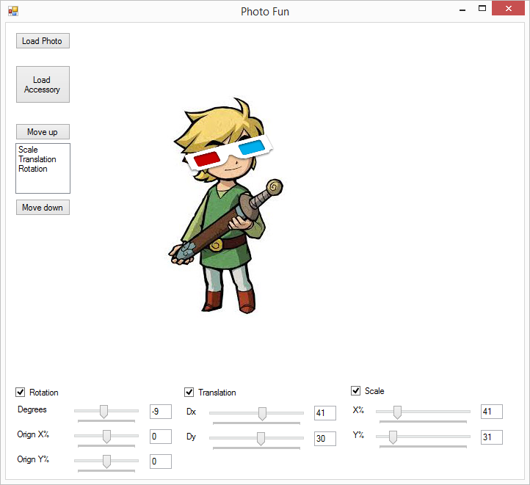

You are required to make an application similar to the example photo fun. The app should satisfy the following.

1. Load two images from files.
2. Allow user to manipulate image via sliders or values.
3. Manipulate one image using matrix transformations.
4. Allow the user to change the order of transformations.
5. You must write your own vector3 and matrix classes (may have done this already).

OrignX and OrignY describe the point of rotation relative to the image ie. (0,0) is the top left corner, (50,50) is the centre and (100,100) is the bottom right corner.

Some code from the example

public partial class Form1 : Form

{

Bitmap accessory, photo;

Point[] points = new Point[3];

Point[] photoPoints = new Point[3];

…

private void Form1_Paint(object sender, PaintEventArgs e)

{

if (photo != null)

e.Graphics.DrawImage(photo, photoPoints);

if (accessory!= null)

e.Graphics.DrawImage(accessory, points);

}

public Form1()

{

InitializeComponent();

accessory = (Bitmap)Bitmap.FromFile(@"Content\baseball.png");

points[0] = new Point(100, 50);

points[1] = new Point(accessory.Width + 100, 50);

…

private void Update()

{

Reset();

for (int i = 0; i < lstOrder.Items.Count; i++)

{

if (lstOrder.Items[i] == "Rotation")

{

RotatePoints();

}

if (lstOrder.Items[i] == "Translation")

{

TranslatePoints();

}

if (lstOrder.Items[i] == "Scale")

{

ScalePoints();

}

}

this.Refresh();

}

private void txtScaleX_TextChanged(object sender, EventArgs e)

{

int value = 0;

if (int.TryParse(txtScaleX.Text, out value))

{

if (value >= trkScaleX.Minimum && value <= trkScaleX.Maximum)

{

trkScaleX.Value = value;

}

}

Update();

}

private void btnUp_Click(object sender, System.EventArgs e)

{

int index = lstOrder.SelectedIndex;

if ((index) <= 0) return;

string s = (string)lstOrder.Items[index];

lstOrder.Items.RemoveAt(index);

lstOrder.Items.Insert(index - 1, s);

lstOrder.SelectedIndex = index - 1;

Update();

}

public static Matrix3 **Rotation(int _angle)**

**public static Matrix3 Translate(int dx, int dy)**

**public static Matrix3 Scale(int dx, int dy)**

This project should be finished by Wednesday 25th February and save the project folder to zip file named “Lab9(yourname).zip” make sure to include a known issues comment even if “Every works”.

There is no need to add extra functionality or include a sketch for this project.

Design doc due 11/2/16 in class(afternoon).

Marking Scheme:

Design Doc multiplier (50%, 75%, 90%, 100%)  
Functionality 75%  
Code quality 25%  
Comments -25%  
Names -25%